***Introducing IPv4 Static Routing***

The ability for a router to take a packet and determine where it needs to go.

What route does a router know by default. The short and long answer is none.

The router only knows how to get to something by a directly connected network. If you open up an interface and change it to up and then give it an IP address that router now knows about that route that is directly connected. Although there are broadcast protocols to talk to other routers to learn their routes. This is the basic learning of a router.

Using Dynamic updates / routing protocol you can learn the updates from other routers.

***Adding Directly Connected IPv4 Routes***

Network 10.1.0.10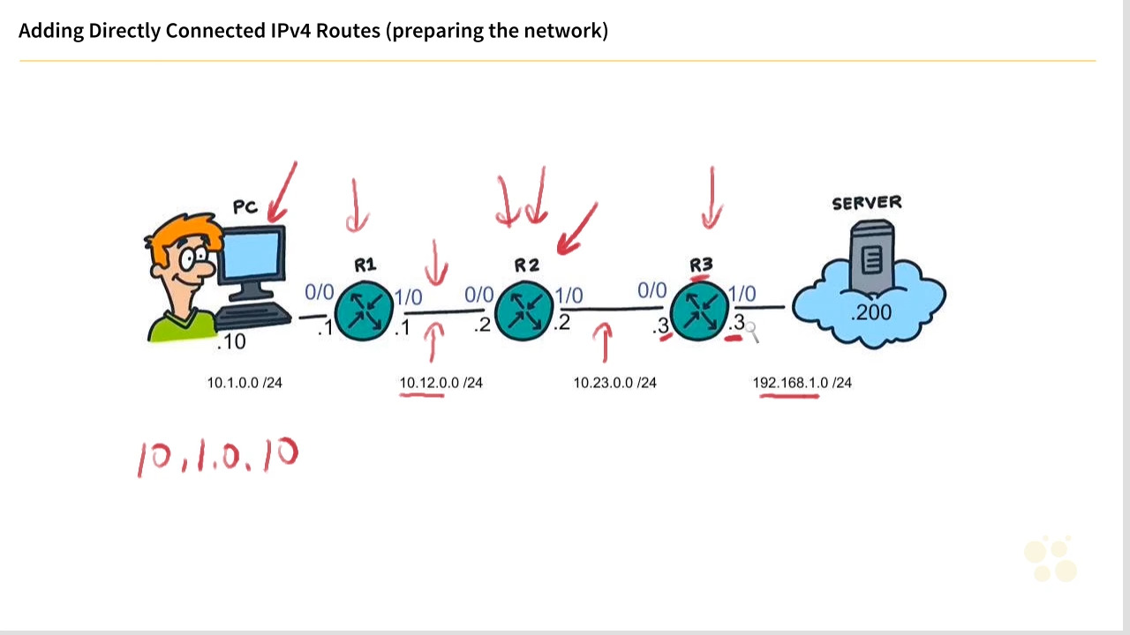

Show ip route

Show ip int brief

To add a directly connected route on a default router interface, which interface-related commands are required? (Choose two)

No shutdown

Ip address 12.34.1.3 255.255.255.0

***Planning Static Network Routes***

When you are planning out your network. Write down each step and ip address configuration. This way when you are going to go configure the routes. You have a template and plan to execute. This way you have a clear road map of what your going to do and how your going to accomplish all the tasks laid out.

When creating a static route, the router should be able to reach the forwarding router's address used in the static route. True or false? TRUE

***Configuring Static IPv4 Network Routes***

Which of the following are true regarding the following command? ip route 10.8.2.0 255.255.255.0 10.16.9.1 (Choose 3)

10.8.2.0 /24 is the destination network

The forwarding router is at 10.16.9.1

The command adds a static route.

|  |  |  |  |  |
| --- | --- | --- | --- | --- |
| R | Command | Destination prefix | Prefix mask | Forwarding routing interface |
| R1 | Ip route | 10.23.0.0 | 255.255.255.0 | 10.12.0.2 |
| R1 | Ip route | 192.168.1.0 | 255.255.255.0 | 10.12.0.2 |
| R2 | Ip route | 10.1.0.0 | 255.255.255.0 | 10.12.0.1 |
| R2 | Ip route | 192.168.1.0 | 255.255.255.0 | 10.23.0.3 |
| R3 | Ip route | 10.1.0.0 | 255.255.255.0 | 10.23.0.2 |
| R3 | Ip route | 10.12.0.0 | 255.255.255.0 | 10.23.0.2 |

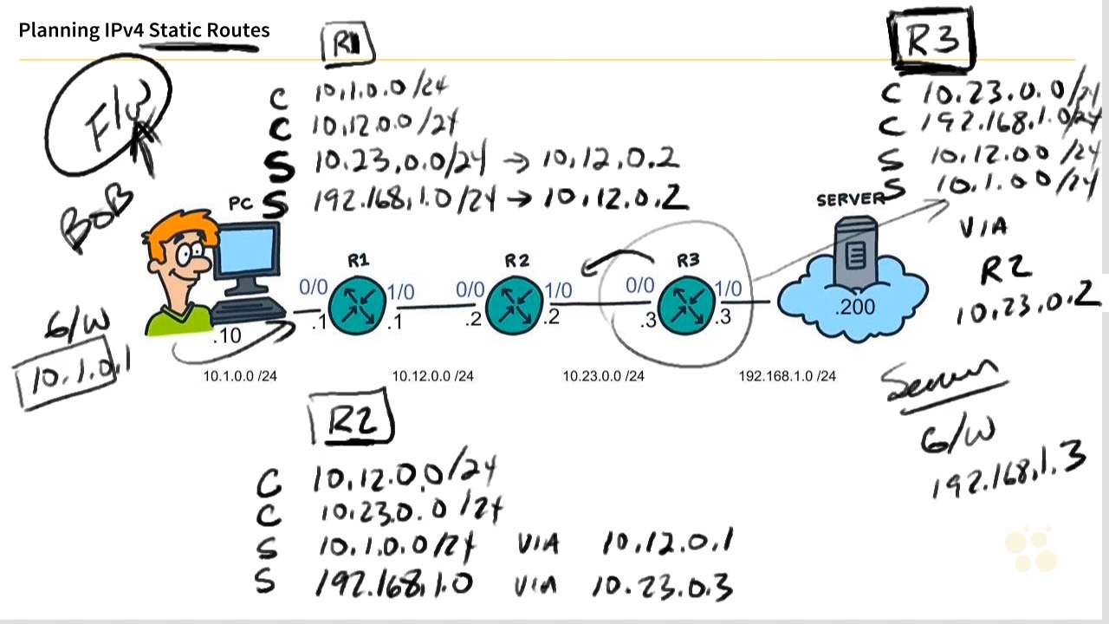

To test to make sure the ping works and your not just talking to the router but the interface you can do an extended ping.

#ping ip 10.1.0.1 source 192.168.1.3

Which of the following is the correct syntax for a static route of 10.0.0.0 /16 if the next hop should be 23.4.5.6?

Ip route 10.0.0.0 255.255.0.0 23.4.5.6

***Adding Static Host Routes***

This loop back interfaces allow you to communicate with the host.

A way you can add this interface is:

R3>#int loop 0

R3># ip address 3.3.3.3 255.255.255.255

Then on r2 you can create the static route by adding

R2>#ip route 3.3.3.3 255.255.255.255 10.23.0.0

Which of the following is an example of valid syntax that will result in the implementation of a static host route?

Ip route 1.2.3.4 255.255.255.255 4.3.2.1

The biggest difference between a static network route and a static host route is that a host route is specific to exactly one 32-bit IP address. True or false?

True

***Implementing Static Default Routes***

Ip route 0.0.0.0 0.0.0.0 [next hop address]

R1>#ip route 0.0.0.0 0.0.0.0 10.12.0.2

Which of the following is the correct syntax for a default static route if the next hop is 10.67.83.1?

ip route 0.0.0.0 0.0.0.0 10.67.83.1

***Floating Static Routes Overview***

A floating static route is when you have the default route and another route have the same weight in value. By editing the administrative distance of the non default route increasing the administrative distance. You create a floating route that will not be used until the default route goes down.

Which of the following is the default Administrative Distance (AD) for a static route? 1

Which of the following causes a floating route to NOT be used in the routing table?

Another route for the same network has a lower(better) Administrative Distance (AD)

***Configuring and Verifying Static Floating Routes***

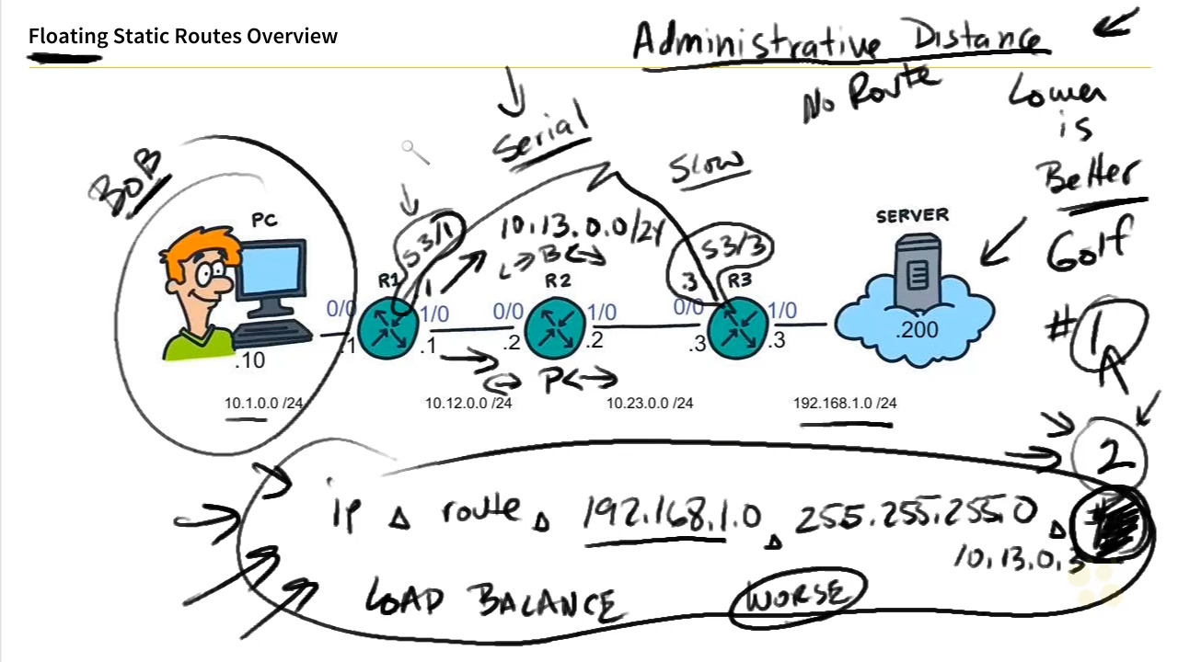

R1># ip route 192.168.1.0 255.255.255.0 10.13.0.3

R1>#do show ip route static

R1># traceroute 192.168.1.200

We need to turn off load balancing for the default and normal static route

R1># ip route 192.168.1.0 255.255.255.0 10.13.0.3 55

R1>#do show ip route

Why does a valid floating static route NOT show up in the routing table?

A better route with a lower AD is in the table already

***Static routes using an outbound interface***

What is the purpose of an exit interface.

Ip route 192.168.1.0 255.255.255.0 10.12.0.2

So the 10.12.0.2 is the static route Ip address. In this case we can add the outbound interface of S3/1. So instead of using the ip address we are going to use the serial address.

Ip route 192.168.1.0 255.255.255.0 serial 3/1

Arp request on a router allows you to discover devices next to it through their mac address.

If a static route uses an Ethernet address as the egress interface, you can include the egress interface in the static route command as long as you include the next hop IP address. True or false?

TRUE

On a point-to-point network, such as a serial connection using PPP, it's okay to only specify the egress (outbound or exit) interface instead of the IP address of the next hop router. True or false?

TRUE

***IPv4 Static Routes Review***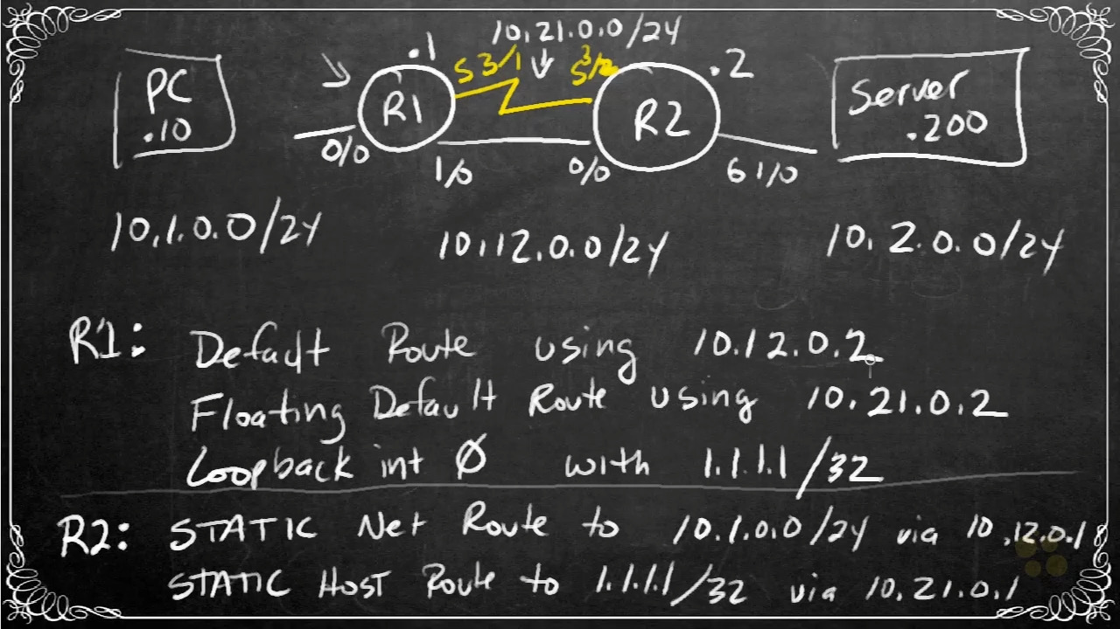

Creating the default and default floating routes

R1>#ip route 0.0.0.0 0.0.0.0 10.12.0.2

R1>#ip route 0.0.0.0 0.0.0.0 10.21.0.2 5

Create a loop back interface

R1>#int loopback 0

R1>#ip address 1.1.1.1 255.255.255.255

R2>#ip route 10.1.0.0 255.255.255.0 10.12.0.1

R2>#ip route 1.1.1.1 255.255.255.255 10.21.0.1

Show ip route static

Traceroute 10.1.0.10

